I. Use Case Description
Use Case Name | Anticipated Diagnosis for Heart Disease
Use Case Identifier | HD-001
Source | PHO - Heart Disease
Point of Contact | Gia Oriana Santos santog@rpi.edu
Creation / Revision Date | 1/19/2026
Associated Documents

II. Use Case Summary
Goal | To inform a user whether they may be at elevated risk for heart disease and should seek evaluation by a medical professional before experiencing severe or acute symptoms (e.g., heart attack, heart failure, arrhythmia).  This use case supports risk awareness and early intervention, not clinical diagnosis.
Requirements | The anticipated diagnostic assessment considers:  - Lifestyle factors: diet, physical activity, smoking, alcohol consumption, recreational drug use  - Existing medical conditions: obesity, diabetes, hypertension, hyperlipidemia  - Family medical history: presence of cardiovascular or related chronic diseases  - Demographic background: age, sex, race, ethnicity  Clinical reasoning and risk assessment should align with American Heart Association (AHA) guidelines and leverage standardized medical terminologies.
Scope | This use case primarily targets middle-aged and older adults (40+) in the United States, as this population is more likely to develop heart disease and aligns with AHA clinical guidelines.  Out of scope:  - Individuals already diagnosed with any form of heart disease  - Clinical decision-making or definitive diagnosis  - Emergency or acute care scenarios  - Use by patients experiencing severe symptoms (e.g., chest pain, shortness of breath)  While designed for U.S. adults aged 40+, individuals outside this demographic may still find the system useful for:  - Preliminary risk awareness  - Lifestyle guidance  - Informational support prior to seeking medical advice
Priority | N/A
Stakeholders | - Primary Stakeholders:  - Middle-aged and older U.S. adults (40+)  - Individuals with known cardiovascular risk factors (e.g., high blood pressure, high cholesterol, diabetes, obesity)  - Secondary Stakeholders:  - Individuals under 40 or outside the U.S. with cardiovascular risk factors  - Cardiologists, primary care physicians, and other healthcare professionals who may use the system as a decision-support or screening aid
Description | Heart disease is an umbrella term encompassing multiple conditions that affect heart function. In the United States, heart disease remains a leading cause of death, with many individuals remaining asymptomatic until a serious event occurs.  Certain forms of heart disease are often “silent,” meaning individuals may not experience noticeable symptoms until the disease has significantly progressed. Common risk factors include increasing age, hypertension, high cholesterol, diabetes, obesity, smoking, physical inactivity, and poor diet. Additional factors such as sex, ethnicity, and family history further influence risk.  This use case focuses on anticipated diagnosis, enabling users to recognize elevated risk early and seek medical evaluation before the onset of severe or irreversible outcomes. The ultimate objective is to promote earlier clinical engagement and healthier lifestyle choices.
Actors / Interfaces | Primary Actor  - Middle-aged and older U.S. adults (40+) who are concerned about potential heart disease risk  Secondary Actors  - Individuals outside the target demographic who possess cardiovascular risk factors  - Healthcare professionals using the system for screening or decision support  Resources  - SNOMED CT and HL7 FHIR–based ontologies for clinical concept standardization  - FHIR® (Fast Healthcare Interoperability Resources®) for integration with Electronic Health Records (EHRs)  - American Heart Association (AHA) guidelines for clinical risk assessment logic
Pre-conditions | - The user has access to their Electronic Health Records (EHR), or can accurately self-report medical history  - The user has basic knowledge of their lifestyle habits  - The user is aware of relevant family medical history  - Application is downloaded and running
Post-conditions | - The user gains an informed understanding of their potential risk for heart disease  - The user is advised whether seeking medical evaluation is recommended  - No formal diagnosis is made  - Application updates the user’s patient profile (PHKG) with added EHR data, lifestyle habits, medical history, and informal diagnostic summaries and recommendations.  - Application returns a percentage score of the anticipated risk levels of various heart diseases
Triggers | User initiates a heart disease risk assessment
Performance Requirements | - The system should provide results within a reasonable time frame for interactive use  - Risk explanations should be understandable to non-expert users
Assumptions | - Users provide accurate and honest information  - Clinical guidelines used are current and validated  - The system is used as an informational and decision-support tool, not a replacement for professional medical advice
Open Issues | - Determining acceptable confidence thresholds for recommending medical follow-up  - Handling incomplete or missing user data  - Addressing ethical and legal disclaimers related to medical decision support

III. Usage Scenarios

- A 52-year-old woman living in Baltimore, Maryland is preparing for an upcoming annual wellness visit but has not yet met with her primary care physician. She is not experiencing acute cardiovascular symptoms such as chest pain, shortness of breath at rest, or irregular heart rhythms. However, she is concerned about her long-term cardiovascular health due to a significant family history: her father was diagnosed with coronary artery disease in his late 50s, and her mother has type 2 diabetes. The user works a sedentary office job and exercises inconsistently. Her diet is high in processed foods, and although she quit smoking five years ago, she previously smoked socially for many years. She consumes alcohol occasionally. During a recent routine check-up, she was informed that her cholesterol levels were borderline high, and she has also been diagnosed with prediabetes but has not yet started medication.
- A 32-year-old man living in Austin, Texas begins experiencing intermittent fatigue and mild shortness of breath during physical activity that previously felt routine, such as climbing stairs or going for short runs. He does not report chest pain, dizziness, or symptoms severe enough to require emergency care, but he is concerned due to his family history of heart disease. His mother was diagnosed with coronary artery disease in her early 50s, and his maternal grandfather died of a heart attack. The user generally maintains an active lifestyle but works a high-stress job with long hours and inconsistent sleep. He does not smoke and drinks alcohol occasionally, though his diet relies heavily on takeout meals. He has not been diagnosed with any chronic conditions and has not undergone recent cardiovascular screening.

IV. Basic Flow of Events

Basic / Normal Flow of Events
Step | Actor (Person) | Actor (System) | Description
1 | patient |  | patient initiates assessment
2 |  | assessment | The system presents informed consent and a disclaimer that the assessment is informational only and doesn't provide a medical diagnosis
3 | patient |  | patient agrees and authorizes access to available health data or chooses manual data entry
4 |  | assessment | The assessment retrieves relevant medical history from patients EHR
5 |  | assessment | The assessment prompts the user to manually fill out any information not included in their EHR
6 | patient |  | patient manually enters information not mentioned in their EHR to the assessment system (patient demographics, medical history, clinical data)
7 |  | assessment | system maps all patient-related data to standardized clinical concepts using appropriate medical terminologies and data models
8 |  | assessment | The system evaluates integrated data against evidence-based guidelines (AHA) to identify cardiovascular risk factors
9 |  | assessment | systems determines anticipated risk levels (percentage score) of various types of heart diseases based on the presence and combination of risk factors
10 |  | assessment | The system generates a clear, non-diagnostic summary of identified risk factors, how they contribute to overall risk, and whether follow-up with a healthcare professional is recommended
11 | patient |  | patient reviews the assessment and recommendations

V. Alternate Flow of Events
Narrative: The alternate flow defines the process/data/work flow that would be followed if the use case enters an error or alternate state from the basic flow defined, above. A summary paragraph should be included that provides an overview of each alternate flow, followed by more detail expressed via the table structure.

Patient Has No Access to EHR
Step | Actor (Person) | Actor (System) | Description
1 | patient |  | patient initiates assessment
2 |  | assessment | The system presents informed consent and a disclaimer that the assessment is informational only and doesn't provide a medical diagnosis
3 | patient |  | patient agrees and authorizes access to available health data or chooses manual data entry
4 |  | assessment | assessment prompt the user that the system doesn't have access to the EHR
5 |  | assessment | The assessment prompts the user to manually fill out their patient demographics (name, address, age, race, gender, religion, etc.)
6 | patient |  | Patient manually fills out their demographics
7 |  | assessment | The assessment prompts the user to fill out their medical history in the form of a survey (Past illnesses, surgeries, family history, lifestyle factors).
8 | patient |  | Patient manually fills out their medical history
9 |  | assessment | Assessment prompts the patient to fill out their clinical data in the form of a survey (current and past medication, immunization records, vital signs, allergies, signs and symptoms, etc.).
10 | patient |  | The patient fills out a survey regarding their clinical data
11 |  | assessment | system maps all patient-related data to standardized clinical concepts using appropriate medical terminologies and data models
12 |  | assessment | systems determines anticipated risk levels (percentage score) of various types of heart diseases based on the presence and combination of risk factors
13 |  | assessment | The system generates a clear, non-diagnostic summary of identified risk factors, how they contribute to overall risk, and whether follow-up with a healthcare professional is recommended
14 | patient |  | patient reviews the assessment and recommendations

Patient Doesn’t Approve Consent
Step | Actor (Person) | Actor (System) | Description
1 | patient |  | patient initiates assessment
2 |  | assessment | system presents informed consent and disclaimer that assessment is informational only and doesnt provide a medical diagnosis
3 | patient |  | patient disagrees to the terms of agreement of the system
4 |  | assessment | system ends without performing anticipated diagnostic assessment

VI. Use Case and Activity Diagram(s)
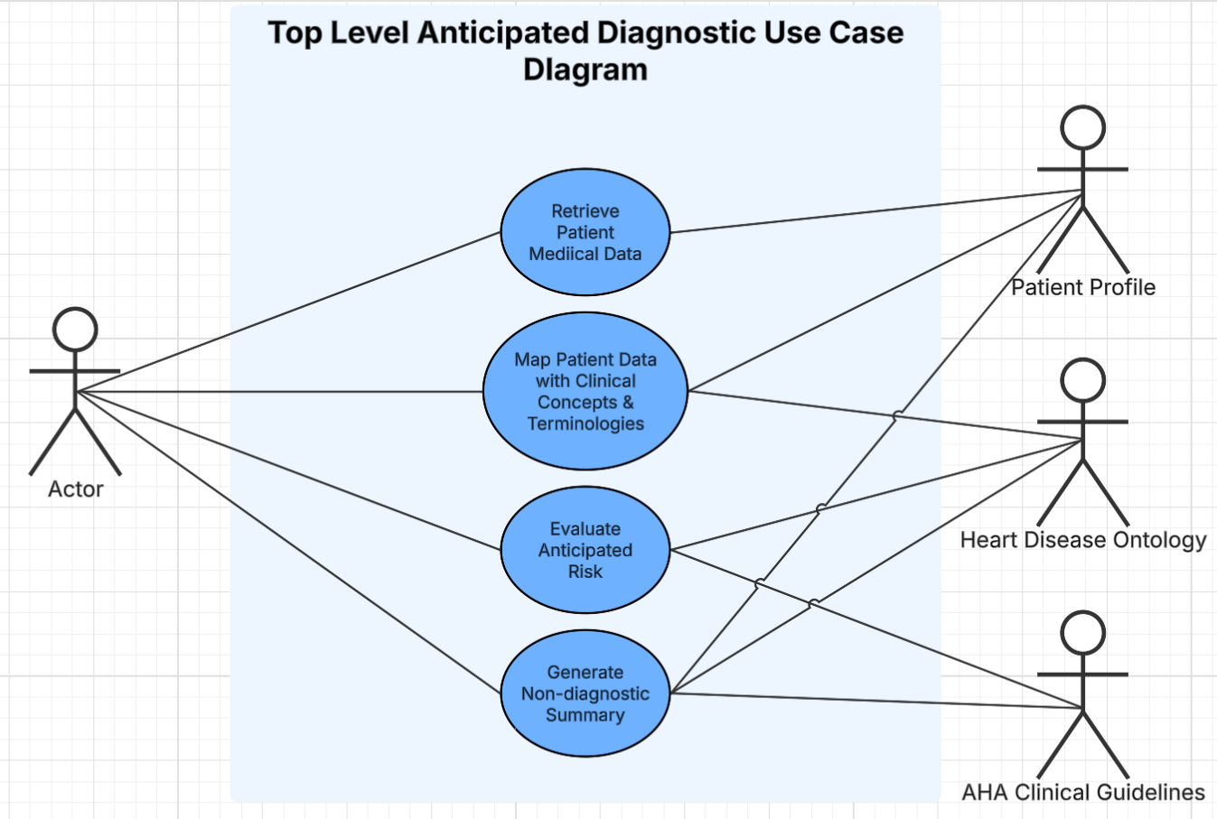
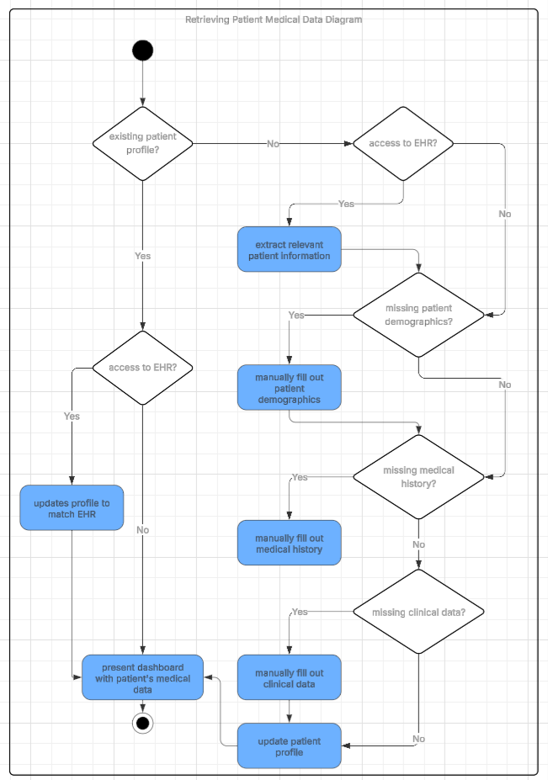
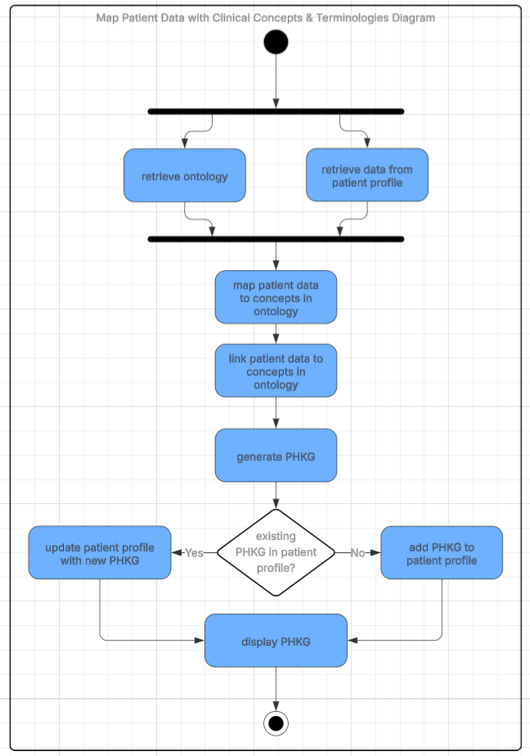
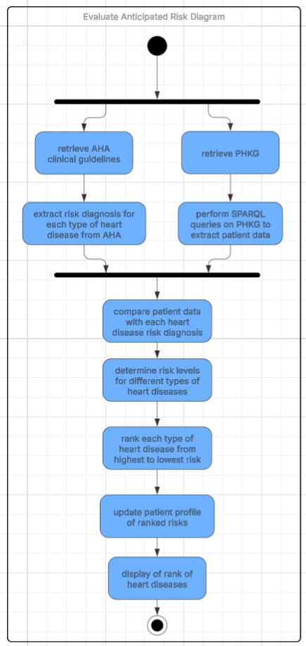
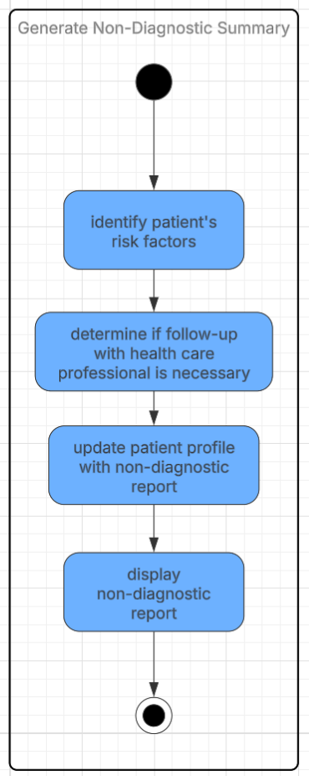

VII. Competency Questions

1. Refer to user story 1. Which risk factors most strongly contribute to an individual’s anticipated risk of heart disease based on current clinical guidelines?
Answer: Age (52 years old), family history (father diagnosed with coronary artery disease and mother has type 2 diabetes), diagnosis (prediabetic), high cholesterol, sedentary lifestyle, physical inactivity, unhealthy diet (high in processed foods), history of smoking (5 years ago), alcohol consumption (occasional)
Determining the answer:
- Load standardized clinical risk factors into the knowledge graph using SNOMED CT and HL7 FHIR representations.
- Map user-provided and EHR-derived data to these standardized risk factor concepts.
- Query the graph to identify which risk factors are present and how they interact according to AHA guidelines.
- Rank or categorize risk contributors based on clinical significance and guideline-defined weighting.
Additional contextual data (e.g., duration or severity of conditions) may be required to refine the prioritization of risk factors.
2. Refer to user story 2. Does the user’s strong family history of heart disease and mild exertional symptoms meet criteria for early cardiovascular screening?
Answer: Yes. The following factors contribute to recommended early cardiovascular screening: family history (mother’s premature diagnosis of coronary artery disease, maternal grandfather passing away of a heart attack), mild symptoms (intermittent fatigue, mild shortness of breath in physical activity)
Determining the answer:
- Load age-based screening thresholds from AHA guidelines into the knowledge graph.
- Augment the graph with family history data and reported symptoms.
- Apply semantic rules that override age-based exclusions when family history and symptoms are present.
- Query whether guideline exceptions for early evaluation are met.
Additional symptom severity or duration data may be required to refine the recommendation.
3. Refer to user story 1. What are the vital signs the user is reporting?
Partial Answer: It depends on what is on the user’s EHR if they load it into the anticipated diagnostic assessment for heart disease
Determining the answer:
- Query the knowledge graph for user-reported or clinically measured vital sign entities associated with the user (e.g., blood pressure, heart rate, respiratory rate, oxygen saturation, body temperature).
- Check for linked EHR data sources (FHIR Observation resources or equivalent) that provide recent, timestamped vital sign measurements.
- Apply semantic classification rules to distinguish: Vital signs (objective, measurable physiological values) and Symptoms (subjective experiences such as fatigue or exertional shortness of breath).
- If no vital sign observations are present, classify vital signs as “not reported” or “unknown” rather than inferred.
- If EHR data are present, retrieve the most recent valid measurements and associate them with standard clinical vocabularies (e.g., LOINC, SNOMED CT).
- Return the result indicating: Which vital signs are available, Which are missing, Whether additional clinical measurements are recommended for risk stratification
4. Refer to usage scenario 2. What are the user’s lifestyle behaviors?
Answer: generally active, high-stress occupation, inconsistent sleep schedule, unhealthy diet (takeout meals), occasional consumption of alcohol
Determining the answer:
- Extract lifestyle-related entities from the user’s input.
- Map extracted behaviors to standardized ontology concepts.
- Query any lifestyle-related entities of the user
5. Refer to usage scenario 1. What type of heart disease does this user have an elevated risk of?
Answer: atherosclerotic cardiovascular disease (ASCVD). Family history: father with coronary artery disease and mother with type 2 diabetes. High cholesterol. Prediabetic. Lifestyle factors: sedentary occupation, lack of exercise, unhealthy diet consisting of processed foods, and a history of smoking. Age (52 years old)
Determining the answer:
- Load HDO ontology to help determine what type of heart disease the user most likely has an elevated risk of.
- Map the user-provided and EHR-provided data in a KG.
- Query all the user-related data present in each heart disease for risk factors.
- Rank all heart diseases from most to least demonstrated risk factors

VIII. Resources

In order to support the capabilities described in this Use Case, a set of resources must be available and/or configured. These resources include the set of actors listed above, with additional detail, and any other ancillary systems, sensors, or services that are relevant to the problem/use case.

Knowledge Bases, Repositories, or other Data Sources
Data | Type | Characteristics | Description | Owner | Source | Access Policies & Usage
(dataset or repository name) | (remote, local/in situ, etc.) | e.g. – no cloud cover | Short description of the dataset, possibly including rationale of the usage characteristics |  | Source (possibly a system, or remote site) for discovery and access
The Health and Retirement Study | Downloadable in CSV | Has different types of survey data: health care and nutrition, consumption and activities, venous blood, health and well being, diabetes.  Chose this because main patient audience is older Americans.  Health status (hypertension, heart disease, heart attack, and stroke occurrence) | longitudinal panel study that surveys a representative sample of approximately 20,000 people in America, supported by the National Institute on Aging (NIA U01AG009740) and the Social Security Administration.  Provides multidisciplinary data to address important questions about the challenges and opportunities of aging. | University of Michigan, National Institute of Aging | https://hrs.isr.umich.edu/ | Open  Use of public datasets:  https://hrs.isr.umich.edu/data-products/access-to-public-data/conditions-of-use  Traditional license for restricted datasets:  https://hrs.isr.umich.edu/data-products/restricted-data/traditional-license
National Health Interview Survey (NHIS) | Downloadable tabular data into CSV | Covers coronary disease, high cholesterol, heart attacks, and other diseases (repiratory and diabetes)  covers health behaviors like smoking (nicotine or e-cigarrettes)  covers health care usages (blood pressure check, doctor visits, prescription medication use)  covers all ages and races  Limited to America  Data: 2019-2024  why: to capture what demographics are more likely to get heart disease related symptoms (behavioral, age, race, health care visits) | Provide data for analyzing health trends and tracking progress toward achieving national health objectives | Centers for Disease Control and Prevention | https://wwwn.cdc.gov/NHISDataQueryTool/SHS_adult/index.html | Open  About acces linked data:  https://www.cdc.gov/nchs/nhis/documentation/index.html  Access to restricted data requires an application:  https://www.cdc.gov/nchs/nhis/about/index.html
Medicare Current Beneficiary Survey | Downloadable CSV files | socio-demographic and health characteristics (chronic illnesses like heart disease): smoking activity, chronic pain, access to telemedicine, activities of daily living  Demographics: metropolitan area, sex, etc.  Problem: limited to those on Medicare  Why: shows social determinants of health for people with chronic illnesses | Collected data on Medicare beneficiaries’ social and medical risk factors and the relationship between these factors, healthcare utilization, and health outcomes. Can be used to evaluate the effectiveness of health care policy and policy interventions. | Centers for Medicare & Medicaid Services | https://www.cms.gov/data-research/research/medicare-current-beneficiary-survey#/research-statistics-data-and-systems/files-for-order/limiteddatasets/mcbs | Open  About public datasets:  https://www.cms.gov/data-research/research/medicare-current-beneficiary-survey
Heart Disease Dataset | Downloadable CSV file | Attribute Information:  age  sex  chest pain type (4 values)  resting blood pressure  serum cholestoral in mg/dl  fasting blood sugar > 120 mg/dl  resting electrocardiographic results (values 0,1,2)  maximum heart rate achieved  exercise induced angina  oldpeak = ST depression induced by exercise relative to rest, etc..  Problem: updated 7 years ago and participants are not from America | This data set dates from 1988 and consists of four databases: Cleveland, Hungary, Switzerland, and Long Beach V. It contains 76 attributes, including the predicted attribute, but all published experiments refer to using a subset of 14 of them. The "target" field refers to the presence of heart disease in the patient. It is integer valued 0 = no disease and 1 = disease. | Kaggle | https://www.kaggle.com/datasets/johnsmith88/heart-disease-dataset | Open  Kaggle Terms and Conditions:  https://www.kaggle.com/terms
Cardiovascular_Disease_Dataset | Downloadable Excel sheet. Compressed in zip file | Includes data dictionary with attributes such as chest pain type, resting blood pressure, serum cholestorol, fasting blodd sugar, max heart rate, number of major vessels, etc.  Problem: participants in the study are not Americans | acquired from one o f the multispecialty hospitals in India. Over 14 common features. Consists of 1000 subjects with 12 features. This dataset will be useful for building a early-stage heart disease detection as well as to generate predictive machine learning models. | Mendeley Data, V1, doi: 10.17632/dzz48mvjht.1  Doppala, Bhanu Prakash; Bhattacharyya, Debnath (2021) | https://data.mendeley.com/datasets/dzz48mvjht/1 | Open  Mendeley Data: https://data.mendeley.com/about

External Ontologies, Vocabularies, or other Model Services
Resource | Language | Description | Owner | Source | Describes/Uses | Access Policies & Usage
(ontology, vocabulary, or model name) | (ontology language and syntactic form, e.g., RDFS - N3) | If the service is one that runs a given ontology or model-based application at a given frequency, state that in addition to the basic description |  | Source (link to the registry or directly to the ontology, vocabulary, or model where that model is maintained, if available) | List of one or more data sources described by and/or used by the model
SNOMED CT | OWL | CSV | RDF/XML | provides the core general terminology for the electronic health record (EHR). Large in unique concepts and descriptions.  Hosts concepts and terminologies for clinical guidelines of chronic diseases, including some heart diseases. | National Library of Medicine - National Institutes of Health (NLM NIH) | https://bioportal.bioontology.org/ontologies/SNOMEDCT | 50+ mapping from different ontologies including: ICD, Congenital Heart Defects Ontology, Cigarette Smoke Exposure Ontology, Cardiovascular Disease Ontology | Open  Bioportal  Terms & Conditions: https://www.bioontology.org/terms/
ICD-11 | OWL | CSV | RDF/XML | Diff | A biomedical ontology for logical representation of the terms and relations related to the International Classification of Diseases (ICD)  Very detailed classification of various heart diseases  Includes coding tool and API (free) | World Health Organization (WHO) | https://bioportal.bioontology.org/ontologies/ICDO | 50+ mappings from different ontologies, including: SNOMED CT, Cardiovascular Disease Ontology, Cigarette Smoke Exposure Ontology | Open  BioPortal  Terms & Conditions:  https://www.bioontology.org/terms/
Social Determinants of Health Ontology (SOHO) | OWL | CSV | RDF/XML | SOHO has terminologies covering societal factors, such as where a person was born, grew up, works, lives, etc., along with socio-economic and community factors that affect an individual’s health. | Sorcero Health Equity Analytics  Navya Martin (nk495@njir.edu)  James Geller (james.geller@njit.edu) | https://bioportal.bioontology.org/ontologies/SOHO | 20+ mappings from different ontologies including: SNOMED CT, Heart Failure Ontology, ICD-10 | Open  BioPortal  Terms & Conditions: https://www.bioontology.org/terms/
Lifestyle Factor Ontology | OBO | CSV | RDF/XML | Includes different categories of lifestyle factors: nutrition, Socioeconomic factors, Environmental exposures, substance use, physical activities, non-physical leisure time, personal care products and cosmetic procedures, sleep, mental health practices | Lars Juhl Jensen ( lars.juhl.jensen@cpr.ku.dk)  Esmaeil Nourani (esmaeil.nourani@cpr.ku.dk)  Katerina Nastou (katerina.nastou@cpr.ku.dk )  https://www.biorxiv.org/content/10.1101/2024.06.13.598816v2 | https://bioportal.bioontology.org/ontologies/LSFO | 50+ mappings from different ontolgies including: Physical Activity Ontology, FoodOn, SNOMED CT, ICD | Open  BioPortal  Terms & Conditions: https://www.bioontology.org/terms/
Heart Disease Ontology (HDO) | OWL | A comprehensive ontology to supply knowledge of the major heart diseases. the ontology includes the causes, risk factors, symptoms, diagnosis, and treatment. this makes it a good ontology for me to reuse in HD-001 to perform risk analysis and to classify what potential HD the person might have. | Sabahat Sabir https://link.springer.com/article/10.1186/s12872-025-04956-6 | https://github.com/sabahatsabir21/Heart-Disease-Ontology | - reuses ontologies for interoperability (international standardizations)  - schema.org  - SNOWMED CT  - ICD10  - FHIR  - NCIT  - SCDO | Open  Github
Unified Medical Language System (UMLS) | Terminology | The UMLS integrates and distributes key terminology, classification and coding standards, and associated resources to promote creation of more effective and interoperable biomedical information systems and services, including electronic health records. | National Library of Medicine - National Institutes of Health (NLM NIH) | https://www.nlm.nih.gov/research/umls/index.html | Metathesaurus: Terms and codes from many vocabularies, including CPT, ICD-10-CM, LOINC, MeSH, RxNorm, and SNOMED CT. Hierarchies, definitions, and other relationships and attributes.  Semantic Network: Broad categories (semantic types) and their relationships (semantic relations). | Open  Requires UMLS license: https://www.nlm.nih.gov/research/umls/index.html

Other Resources, Service, or Triggers (e.g., event notification services, application services, etc.)
Resource | Type | Description | Owner | Source | Access Policies & Usage
(sensor or external service name) |  | Include a description of the resource as well as availability, if applicable | Primary owner of the service | Application or service URL; if subscription based, include subscription and any subscription owner

IX. References and Bibliography

AHA Clinical Guidelines
UMLS

X. Notes

There is always some piece of information that is required that has no other place to go. This is the place for that information.

